**ASSIGNMENT/ASSESSMENT ITEM COVER SHEET**

**Hossain**

**Sayeed Bin**

**Student Name:**

**FIRST NAME Family / last NAME**

1

7

4

3

3

4

0

**Student Number:**  Email: c3340471@uon.edu.au

**Course Code** **Course Title**

Database Management 2

0

6

0

6

T

F

N

I

*(Example)*  *(Example)*

Intro to University

3

2

1

D

C

B

A

4

Campus of Study: (eg Callaghan, Ourimbah, Port Macquarie)

Callaghan

Assignment 3: Data Marts and Business Intelligence

30 July 2021

Assessment Item Title: Due Date/Time:

Tutorial Group (If applicable): Word Count (If applicable):

Lecturer/Tutor Name:

Kellie Bohlsen

**x**

Extension Granted: Yes No Granted Until:

Please attach a copy of your extension approval

**NB: STUDENTS MAY EXPECT THAT THIS ASSIGNMENT WILL BE RETURNED WITHIN 3 WEEKS OF THE DUE DATE OF SUBMISSION**

**Please tick box if applicable**

*Students within the Faculty of Business and Law, Faculty of Science, Faculty of Engineering and Built Environment and the School of Nursing and Midwifery:*  
I verify that I have completed the online Academic Integrity Module and adhered to its principles

*Students within the School of Education:*  
"I understand that a minimum standard of correct referencing and academic literacy is required to pass all written assignments in the School of Education; and I have read and understood the School of Education *Course Outline Policy Supplement,* which includes important information related to assessment policies and procedures.

I declare that this assessment item is my own work unless otherwise acknowledged and is in accordance with the University’s [Student Academic Integrity Policy](https://policies.newcastle.edu.au/document/view-current.php?id=35&version=1)

**DATE**

**STAMP**

**HERE**

**Insert this way**

I certify that this assessment item has not been submitted previously for academic credit in this or any other course. I certify that I have not given a copy or have shown a copy of this assessment item to another student enrolled in the course.

I acknowledge that the assessor of this assignment may, for the purpose of assessing this assignment:

* Reproduce this assessment item and provide a copy to another member of the Faculty; and/or
* Communicate a copy of this assessment item to a plagiarism checking service (which may then retain a copy of the item on its database for the purpose of future plagiarism checking).
* Submit the assessment item to other forms of plagiarism checking.

I certify that any electronic version of this assessment item that I have submitted or will submit is identical to this paper version.

Turnitin ID:

(if applicable)

Signature: _____________________________________________________________ Date: ___________________ 

30.07.21

Sayeed Bin Hossain

Sayeed Bin Hossain

C3340471

Assessment Item 3

Data Marts and Business Intelligence



Table of Contents

Part 1 - Data Mart Design 1

1.1 Documented Schema (Star Schema) 1

1.2 Subject Area 2

1.3 Information Analysis Needs 3

1.4 Query Examples 3

**Part 1 - Data Mart Design**

* 1. **Documented Schema (Star Schema)**

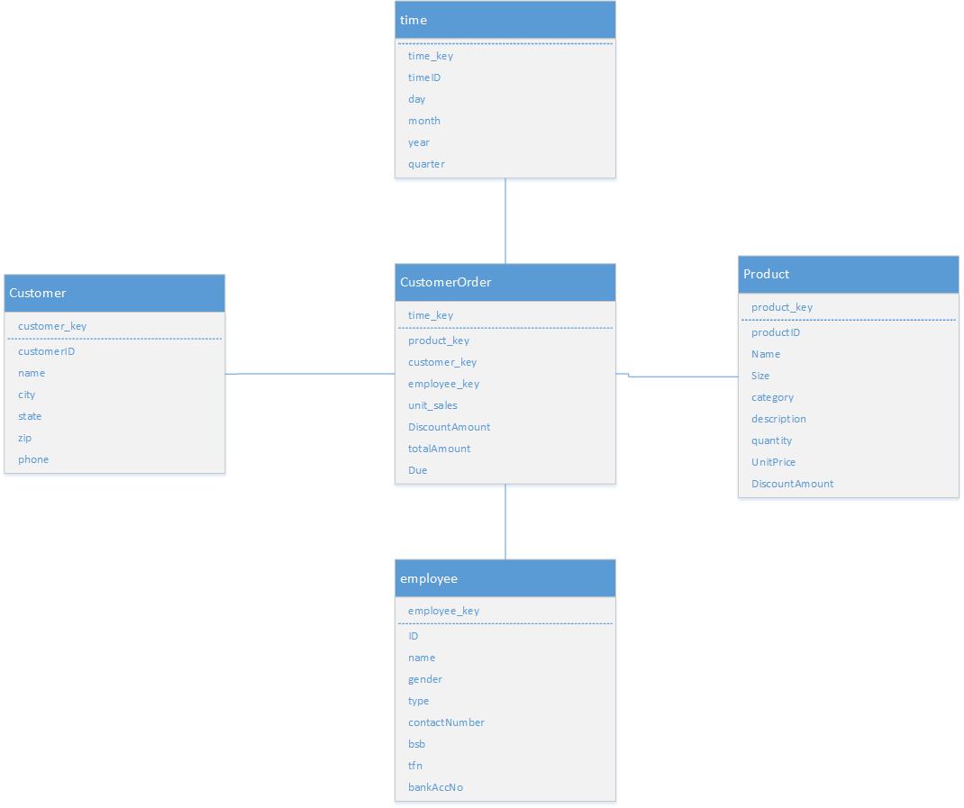

Figure 1: Data Mart Design (Star Schema)

* 1. **Subject Area**

In this data mart, I have focused on the Customer Order part of the business process since it is one of the most important parts of the business and can help to provide great insight into some of the most significant questions. The star schema has been designed following the EER model and business scenario. The dimensions that I have selected are time, product, customer, employee, and promotion. CustomerOrder entity is the fact table that contains facts about each order place by the customers. The Grain of the CustomerOrder table is the individual orders that the customer places and holds details of the orders. Time, Product, Customer, and Employee entities are the dimension tables as they will provide details (measures) of the Fact table.

* 1. **Information Analysis Needs**

The data mart can satisfy the information analysis needs of Tasty’n’Yummy Pizzas in several ways for several scenarios and help the management to take important business decisions. For example, using this data mart, management will be able to identify their best-selling pizza, which area is ordering most pizzas, which location’s customers are ordering more pizzas when the promotion is going on, which category of pizza is selling the most, and so on. They can identify which area’s customers are not ordering and can generate relevant advertisements targeting customers from that area. Similarly, then can get insight into how a particular sector of the business is performing and take necessary business decisions to maximise profit and gain competitive advantages.

* 1. **Query Examples**

1. Total sales of pizza based on the category in a year (2020 for example). Total sales will be calculated by adding all the totalAmount from the Order table, filtering them by using year from Time entity and grouping them by category (product entity). Key from each table will be used to join the tables.
2. Total Sales made by employees based on gender in different years. Total sales will be calculated by adding all the totalAmount from the Order table and then will be grouped by year (Time entity) and gender (employee entity)
3. Total DiscountAmount given on different categories of pizza in a year (2020 for example). Total discountAmount will be calculated from the Order table by adding all the discountAmount, filtering them by year (using where clause) from the Time entity and group by category of pizza (product entity).
4. Total sales based on different locations in a year (2020 for example). Total sales amount will be calculated by adding all totalAmount from the Order table, filtering them by year (2020) from the Time entity and group them by location (customer table).
5. Identity which employee made the most sales in a given year. Total sales will be calculated by adding the totalAmount from customer order entity, filtering them by year from Time entity and getting the employee’s name from employee entity.